**Setting Up Application Environment**

**Create IBM Cloud Account**

|  |  |
| --- | --- |
| Date | 27 October 2022 |
| Team ID | PNT2022TMID17964 |
| Project Name | Skill and Job Recommender Application |
| Team Members: | Mridhul M, Pragadish SA, Megaloshini S, Priyadharshika R |

**Step 1:**

Type or click the below link in the browser [***https://www.ibm.com/academic/home***](https://www.ibm.com/academic/home)

**Step 2:**

Click register icon and give all the details one by one,

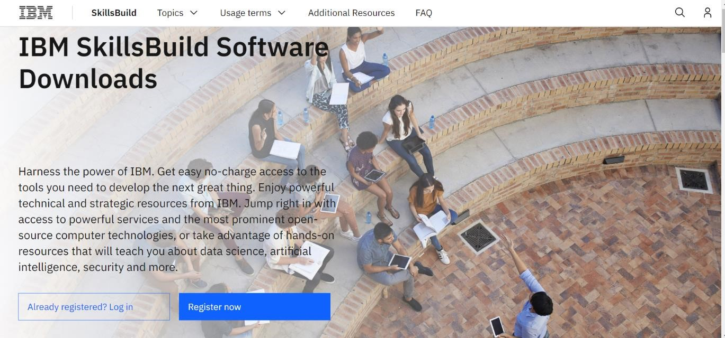

**Step 3:**

Already you got SI EMAIL and SI PASSWORD from your IBM student login. Login to your web mail account. Wait for 7-digit verification code in your web mail: [***https://sg2plmcpnl496936.prod.sin2.secureserver.net:2096/***](https://sg2plmcpnl496936.prod.sin2.secureserver.net:2096/)

**Step 4:**

Get 7-digit verification code in webmail, then go to registration page and enter the verification code.

**Step 5:**

Now, you have successfully created the IBM Cloud Account.

**Step 6**:

Go to IBM Cloud login page: [***https:*** ***//cloud.ibm.com/login***](https://cloud.ibm.com/login) ,then enter your IBM Id and Password.

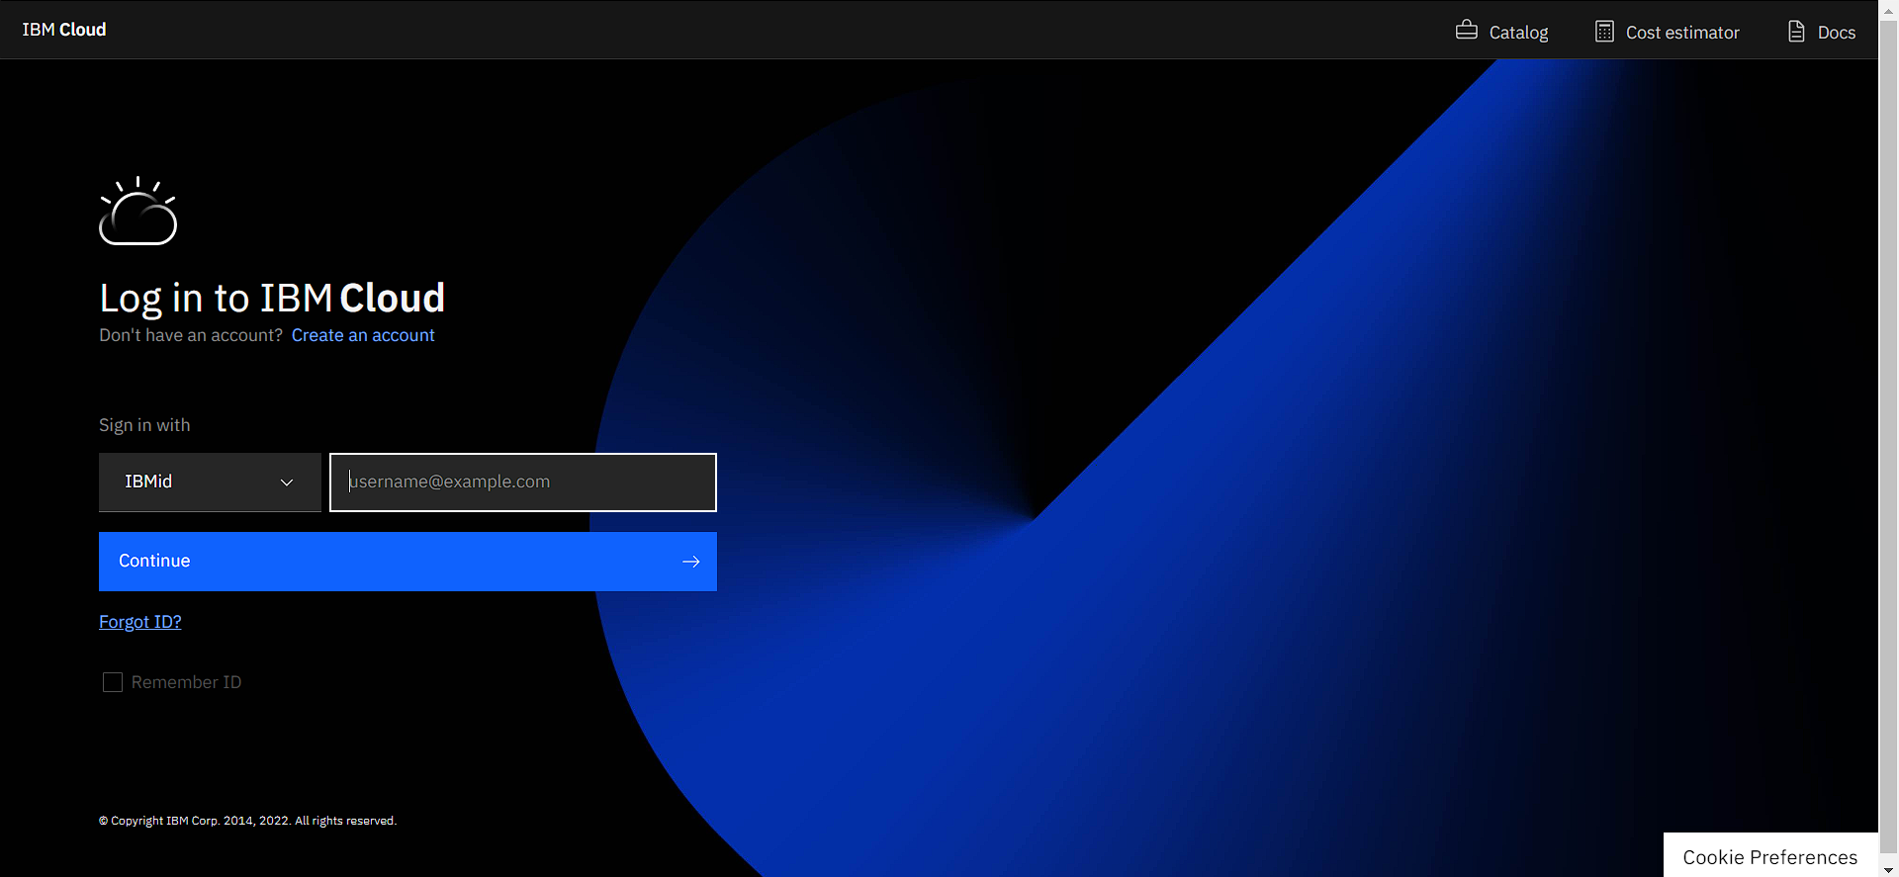

**Step 7:**

Finally, you will access the IBM cloud account.

